mkCSCIU511 OPERATING SYSTEMS

LABORATORY ASSIGNMENT ONE

DEADLINE: SEPTEMBER 23RD

Josh Howard Submission

1. Run the command: mkdir ~/dir1/dir2 How can the error be fixed?

Answer: Running this commands gives “cannot create directory `/home/User/dir1/dir2`: No such file or directory. This can be fixed by creating a `/home/User/dir1` folder.

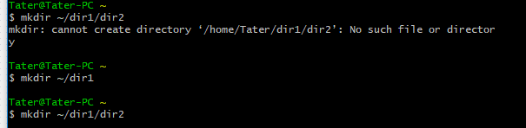

1. The operators <, > and >> important. There's also (unsurprisingly) a << operator. Find out how to use it both and provide 2 examples of each.

Answer: The Operator > and >> are used for standard output. The > is used to overwrite anything in the target file with the new contents, while >> is to add without deleting the original contents.

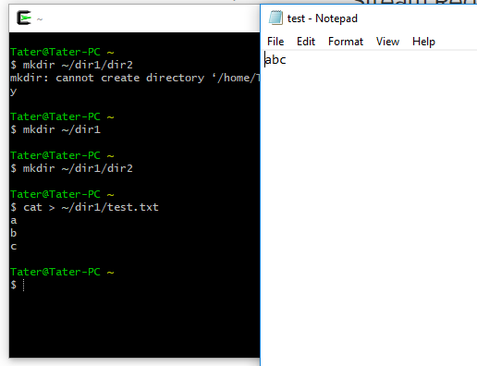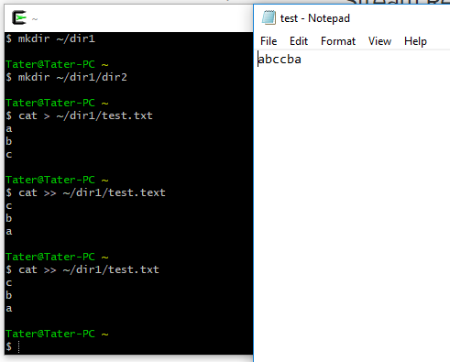

1. Work out what each piece of this command does: cut -f1 -d" " ~/.bash_history | sort | uniq -c | sort -nr | head 10. Add an alias to your configuration file so that running ls (with no additional options) gives a colored output

Answer: “cut” prints out each line of a file to a standard output.  
“-f1” starts each line at spot 1.  
“-d” ” “ tells it to end each line once it’s found the specified character  
“~/.bach_history” is what file to look at  
“sort” sorts the lines in alphabetical order  
“uniq -c” counts each repeated line, adds the number of times it appears as a prefix to the first appearance and removes the rest.  
“sort -nr” then sorts those lines in descending order  
“head 10” prints out the first 10 lines.

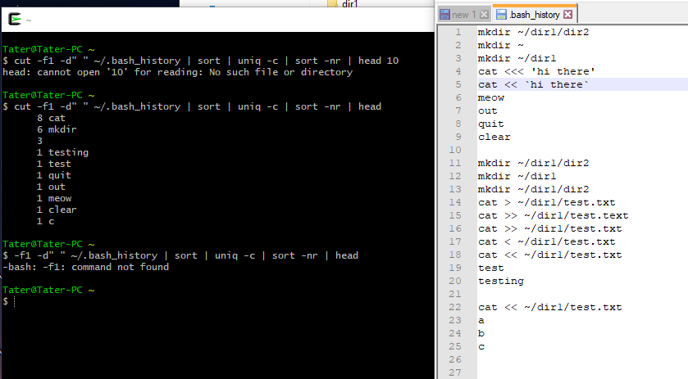

1. Create a directory containing several files. Produce a tarball of that directory. Find out how to compress the tarball both at the same time the tarball is created and after an uncompressed tarball has been created

Answer: “tar -cz” is used to create and compress the tarball at the same sime.

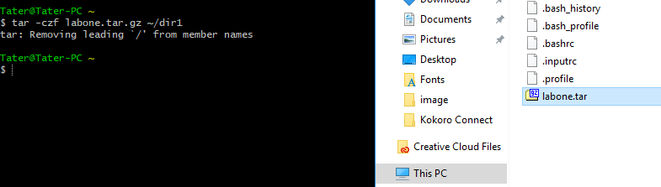

1. Suppose a short-term scheduling algorithm favors those processes that have used little processor time in the recent past.1) Explain why this algorithm favors I/O-bound processes.2) Explain why this algorithm does not permanently deny processor time to CPU-bound processes

Answer: 1) I/O-bound processes take less time to process than CPU-bound. So when looking for little processor use over a given period of time, I/O-bound will be the one the algorithm chooses.

2) After a certain amount of time of running I/O-bound processes, CPU-bound will become the one that’s used less processor time. So the algorithm will then process the CPU one instead, but switch back to I/O once the CPU-bound processes out-weight the I/O.

1. In the Exec II batch system, users would submit a large number of jobs in the morning. These jobs took hours to complete and thereby prevented fast response. Suggest a modification of the scheduling policy that would discourage users from doing this.

Answer: I would say that the shortest-job-first scheduling would fix this problem. Large jobs that take most of the processing time up would now be done later so that the smaller jobs are done quicker. This gives an overall wait time that’s less than before.

1. In the Scope system for the CDC 6600 computer, system resources (processor time, storage, etc.) can remain idle while running jobs wait for operators to mount magnetic tapes. Suggest a solution to this problem

Answer: I would the job scheduling. Make the computer run the CPU-bound processes while the operators are mounting the tapes. Read everything from the tapes, then run the CPU ones while the tapes are changed again. This would have no idle time for the system resources.

1. Consider the following set of processes, their arrival times and expected running times. For each of the following scheduling algorithms, determine the mean process turnaround time and mean waiting time. Ignore process switching overhead.(a) Round Robin (q = 10) (b) First-Come, First-Served (run in alphabetical order) (c) Shortest Job First

|  |  |  |
| --- | --- | --- |
| 1. Process | 1. ERT | 1. Arrival |
| 1. A | 1. 85 | 1. 0 |
| 1. B | 1. 30 | 1. 10 |
| 1. C | 1. 35 | 1. 15 |
| 1. D | 1. 20 | 1. 80 |
| 1. E | 1. 50 | 1. 85 |

Answer: a) turn around time: 153,waiting time: 109

b) turn around time: 148,waiting time: 104

c(Non-preemptive)) turn around time: 143,waiting time: 61

1. Consider a swapping system in which memory consists of the following hole sizes in memory order: 10 KB, 4 KB, 20 KB, 18 KB, 7 KB, 9 KB, 12 KB, and 15 KB. Which hole is taken for successive segment requests of
   1. 12 KB
   2. 10 KB
   3. 8 KB

for First Fit? Now repeat the question for Best Fit, Worst Fit, and Next Fit

Answer: a) FF: 20KB, BF: 12KB, WF: 20KB, NF: 20KB

b) FF: 10KB, BF: 10KB, WF: 18KB, NF: 18KB

c) FF: 18KB, BF: 9KB, WF: 15KB, NF: 9KB

1. A computer has four page frames. The time of loading, time of last access and the R and M bits for each page are as shown below (the times are in clock ticks):

|  |  |  |  |  |
| --- | --- | --- | --- | --- |
| Page | Loaded | Last ref. | R | M |
| 0 | 126 | 280 | 1 | 0 |
| 1 | 230 | 265 | 0 | 1 |
| 2 | 140 | 270 | 0 | 0 |
| 3 | 110 | 285 | 1 | 1 |

For each of these algorithms, which page will be replaced?

Answer: No algorithms listed?